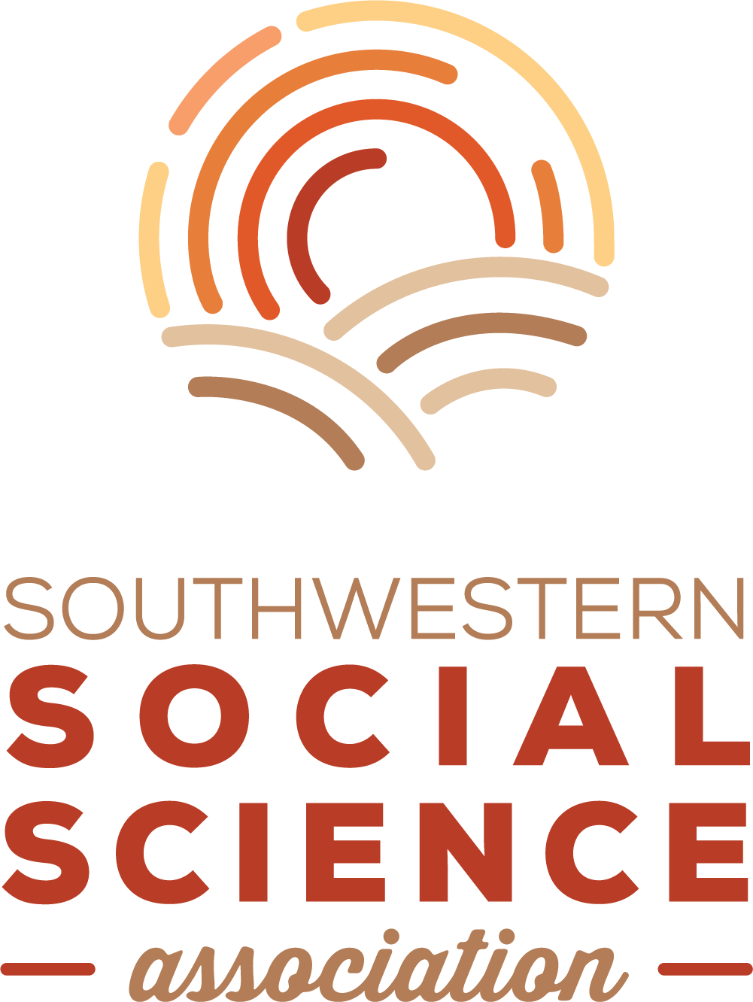
2023 Annual Meeting Student Travel Grant Application

The SSSA Council is pleased to announce availability of student travel grants for our 2023 Annual Meeting in Fort Worth. We will award up to twenty (20) grants in the amount of $300 each, with at least one (1) award provided to an attendee in each of our affiliates (identified as the primary affiliate on the student's membership file). Deadline to apply is March 1. Winners will be notified by March 10, and they will be recognized during the Annual Meeting's award ceremonies and presidential reception.

To qualify, a student must meet these requirements:
- Be a member of the SSSA
- Register for the Annual Meeting
- Have a paper or poster accepted for presentation at the Annual Meeting

To apply, a student needs to submit:
- This travel grant application form
- A current curriculum vita
- A short (one paragraph) statement of need (on the application form)
- A short letter of recommendation from a faculty member familiar with the work.

Email all materials to sssacomsdir@gmail.com.

Student’s name:

College or University:

Title of paper/poster:

Primary SSSA affiliation:
☐ Anthropology ☐ Economics ☐ History ☐ International Studies
☐ Political Science ☐ Social Work ☐ Sociology ☐ Women’s / Gender Studies

Brief statement of need for the travel grant:

Signature Date

