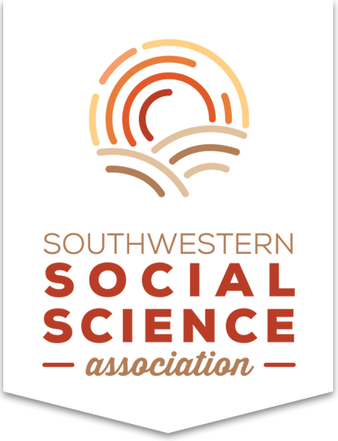
The Southwestern Social Science Association
International Studies
October 10-13, 2018
Hyatt Regency Grand Cypress,
Orlando, Florida

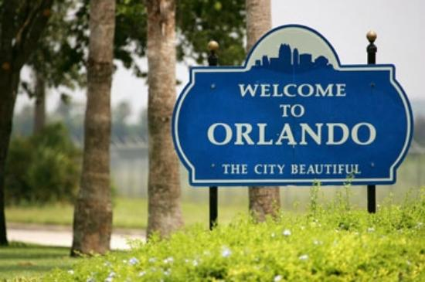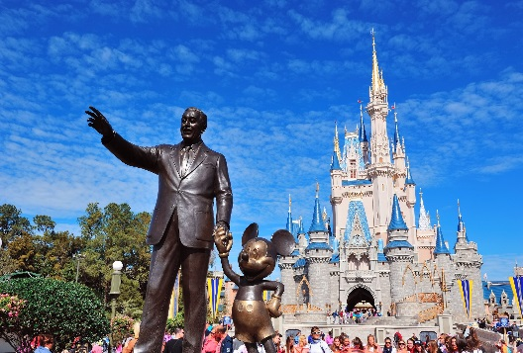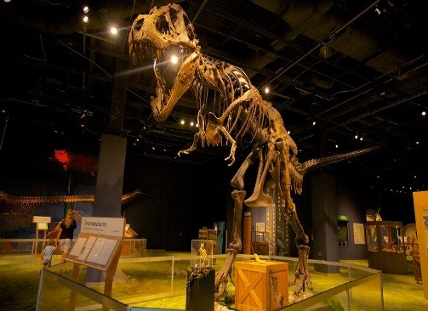
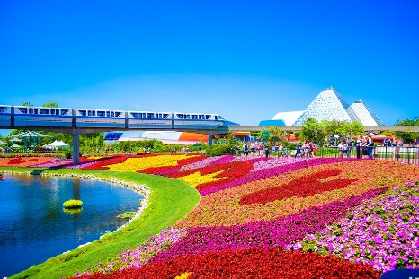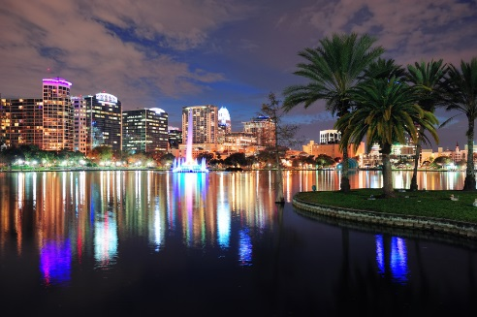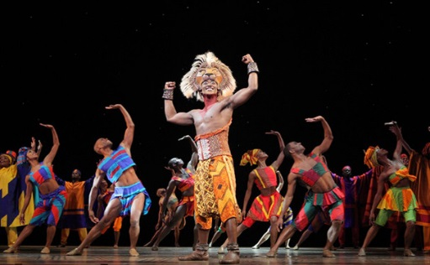
Southwestern International Studies Association members and participants,
You are cordially invited to join us for our 98th Annual Meeting in Orlando, Florida October 10-13, 2018. The theme for the 2018 meeting is “It’s a Small, Small World”, reflecting the ever-increasing interconnectedness of people, systems and academic disciplines. We welcome the participation of all scholars and the presentation of work on all topics, methodologies, and periods or areas in the fields of Anthropology, Economics, History, International Studies, Political Science, Psychology, Sociology, Social Work, and Women and Gender Studies. Our meeting will feature panels, poster sessions, roundtable discussions, and paper workshopping opportunities, both in the individual fields of Social Sciences as well as within an interdisciplinary framework. Find the submission site at https://convention2.allacademic.com/one/sssa/sssa18/
We look forward to your submissions, and seeing you in Orlando!
Program Chair: Dr. Israel Nandamudi e-mail: inandamudi@etbu.edu
Submission Deadline: April 23, 2018

