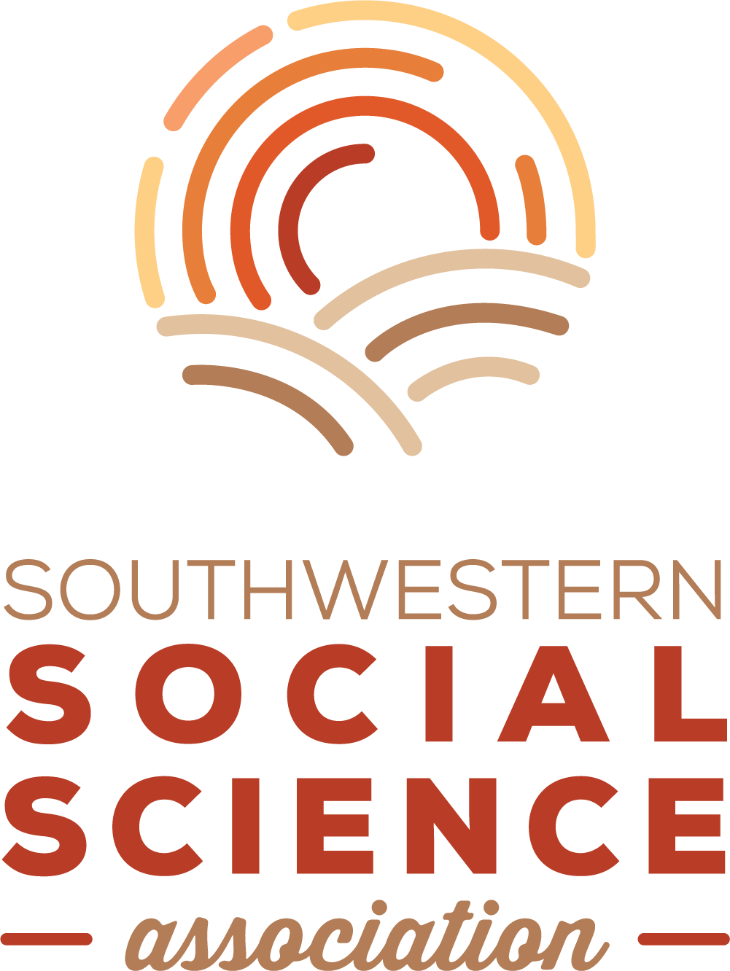
2019 Annual Meeting Student Travel Grant Application

The Southwestern Social Science Association Council is pleased to announce availability of student travel grants for our 2019 Annual Meeting in San Diego. We will award up to ten (10) grants in the amount of $300 each, with at least one (1) award provided to an attendee in each of our affiliates (identified as the primary affiliate on the student's membership file). Deadline to apply is July 31. Winners will be notified by August 30, and they will be recognized during the Annual Meeting's award ceremonies and presidential reception.

To qualify, a student must meet these requirements:
- Be a member of the SSSA
- Register for the Annual Meeting
- Have a paper or poster accepted for presentation at the Annual Meeting

To apply, a student needs to submit:
- This travel grant application form
- A current curriculum vita
- A short (one paragraph) statement of need (enter below, on the application form)
- A short letter of recommendation from a faculty member familiar with the work.

Email all materials to sssacomsdir@gmail.com.

Student’s name:

College or University:

Title of paper/poster:

Primary SSSA affiliation:
__Anthropology __Economics __History __International Studies
__Political Science __Social Work __Sociology __Women’s / Gender Studies

Brief statement of need for the travel grant:

Signature Date

